Simple Static Equilibrium:

1. Two people are sitting on a see-saw. The person on the left weighs 50 kg while the person on the right weighs 65 kg. Calculate the magnitude of the reaction force at the pivot point (ignore the weight of the beam).

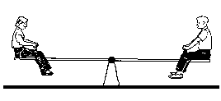

1. A 2 kg sign is suspended by two wires from a wall and a beam. Find the magnitude of the tension in each wire.

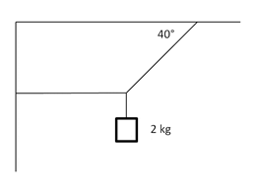

T2

T1

1. A picture is hung on the wall as shown. The string

forms an isosceles triangle with θ = 110˚. The

θ

picture weighs 1.50 kg. Find T1 & T2:

T1

T2

[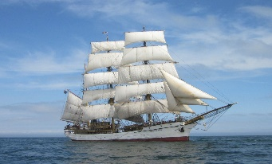](https://www.google.com.au/url?sa=i&url=https%3A%2F%2Fwww.windseeker.org%2Fship%2Fpicton-castle%2F&psig=AOvVaw2d9-1uWu2B3jD5YGORyCs-&ust=1581090793040000&source=images&cd=vfe&ved=0CAIQjRxqFwoTCJjK57OkvecCFQAAAAAdAAAAABAR)